**ORDER OF BUSINESS**

CONSTRUCTION BOARD OF ADJUSTMENT AND APPEALS (CBAA)

# LOCAL CONSTRUCTION REGULATION BOARD (LCRB)

# FLOOD DAMAGE PREVENTION BOARD (FDPB)

# June 12, 2025- 2:00 PM

# 2300 North Jog Road, 1st Floor Room 1W-47

# West Palm Beach, FL. 33411

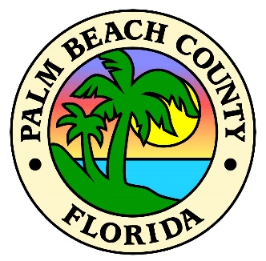

__________________________________________________________________________________________

1. **CALL TO ORDER / CONVENE AS CONSTRUCTION BOARD OF ADJUSTMENT & APPEALS (CBAA)**
   1. **Roll Call**

___ Rex Kirby, Division 1 Contractor, ***Chair*** ___ William Reicherter, Electrical Contractor

___ Jessica Dornblaser, Architect, **Vice Chair** ___ Steven Markel, HVAC Contractor

___ Timothy Wingate, Division 1 Contractor ___ Manuel Oyola, Roofing Contractor

___ Bart Rasper, Plumbing Contractor ___ Michael Riemer, Engineer

* 1. **Approval of Minutes** 
     1. January 9, 2025
  2. **Administer Oath to Witnesses**

1. **ADDITIONS & DELETIONS**
2. **OLD BUSINESS**
   1. **2024-01 -** 6271 17th Drive South Trlr 718 West Palm Beach, FL 33415
3. **NEW BUSINESS**

None

1. **BOARD MEMBERS COMMENTS**

None

1. **STAFF COMMENTS**
   1. **Next meeting scheduled is July 10, 2025.**
2. **ADJOURNMENT**